**Custom Table Macro**

The Custom table Macro Expressions will be used to fetch column field value from a Custom table on passing Custom table name, Unique ID (ItemID or ItemGUID) and Column name in a Macro method under Text/XML, ASCX transformation or any other transformation which supports Macro Expressions.

**Current Scenario:-** If we want to get the value of a column from a Custom table, we have to write the custom method in a class and then call this method under the transformations to get the value.

**Future Scope :-** We have created two Macro Method’s and two Eval Expressions in which we have written the code of Custom Table API to get the value of column in return.

The parameters which we are going to pass in our method are :

1. **Custom Table Name:-** Name of the Custom Table.
2. **UniqueID**:- A unique ID to get the record of the Custom Table from which the field value is to be returned. In the Custom table there are two unique IDs, one is **ItemID** and other is **ItemGUID**.
3. **Column Name**:- Name of the column whose value is to be returned.

**Benefits**: There will be no need to write the custom code to get the required column field value. You just have to pass the three parameters in the macro expression(in Text/XML transformation)/Eval Expressions(in ASCX transformation) and get the column field value in return.

There are two Macro methods that you can use to get the Column value of a Custom table in Text/XML transformation :-

1. To get the value of column from Custom table using ItemGUID:-

* {%GetValueFromCustomTableByItemGUID(CustomTableName,**ItemGUID**,ColumnName)#%}

1. To get the value from Custom table using ItemID :-

* {%GetValueFromCustomTableByItemID(CustomTableName,**ItemID**,ColumnName)#%}

There are two Eval Expressions that you can use to get the Column value of a Custom table in ASCX transformation:-

1. To get the value of column from Custom table using ItemGUID:-

* <%#GetValueFromCustomTableByItemGUID(CustomTableName,**ItemGUID**,ColumnName)%>

1. To get the value from Custom table using ItemID :- -

* <%#GetValueFromCustomTableByItemID(CustomTableName,**ItemID**,ColumnName)%>

**Example** :- Let us understand the use of Macro Expressions and Eval Expressions through a simple example:-

There is a Custom Table named “Custom.Employee” as shown in the below image :

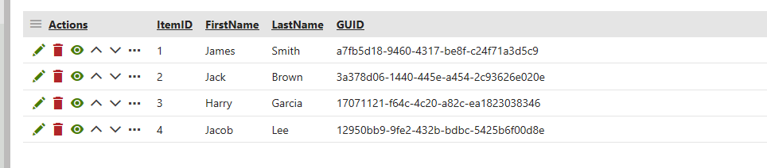

Custom Table

**Use of Macro Expressions in Text/XML Transformation**

Now if you want to get the LastName field value of a user, you basically have two different Macro Expression to do this:-

1. {%String.**GetValueFromCustomTableByItemID**("Custom.Employee","2","LastName")#%}

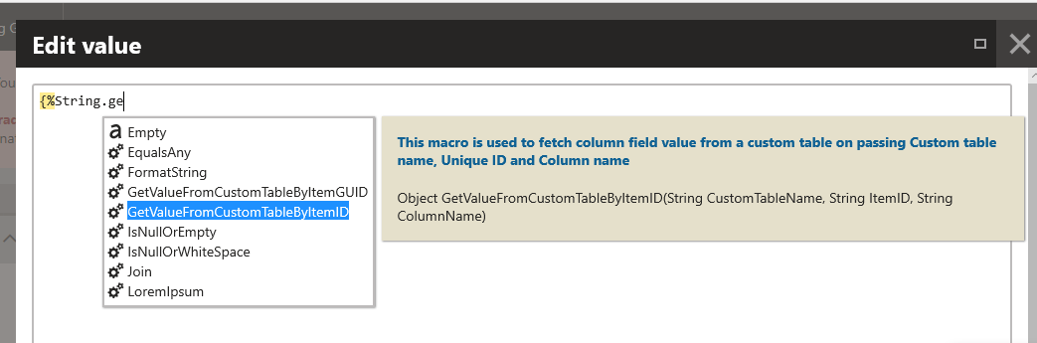

1. {%String.**GetValueFromCustomTableByItemGUID**("Custom.Employee","3a378d06-1440-445e-a454-2c93626e020e","LastName")#%}

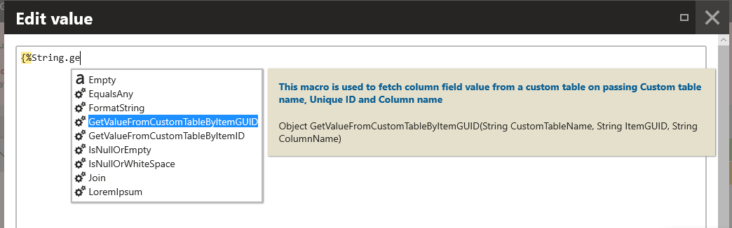

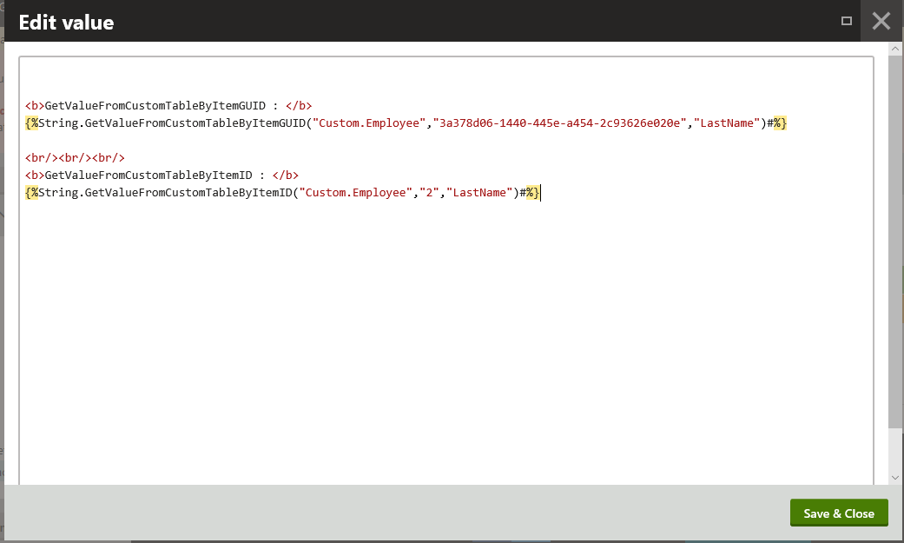

**Output of both the above Macro Expressions:**



**Use of Eval Expressions In ACX Transformation**

Now if you want to get the LastName field value of a user, you basically have two different Eval Expression to do this:-

1. <%#**GetValueFromCustomTableByItemID**("Custom.Employee","2","LastName")%>
2. <%#**GetValueFromCustomTableByItemGUID**("Custom.Employee","3a378d06-1440-445e-a454-2c93626e020e","LastName")%>

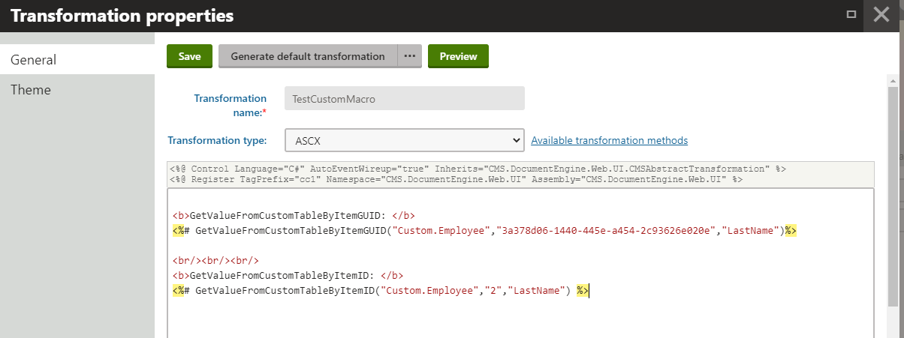

**Output of both the above Eval Expressions :**

